Universal
Coding
in
Python
and
Node.js
by
Christopher Andrew Topalian

All Rights Reserved
Copyright 2000-2024
Dedicated
to
God the Father

node.js
Universal Coding Style
Node.js Universal Coding Style

In this project folder, we have 4 files:
// getTime12.js
// getTime24.js
// Time.js
// usesClassTime.js

getTime12.js is a function
getTime24.js is a function
Time.js is a class that imports our functions
usesClassTime.js uses our Time.js class

We achieve a very pure functional style of coding and enable namespace for our functions using our class import method.
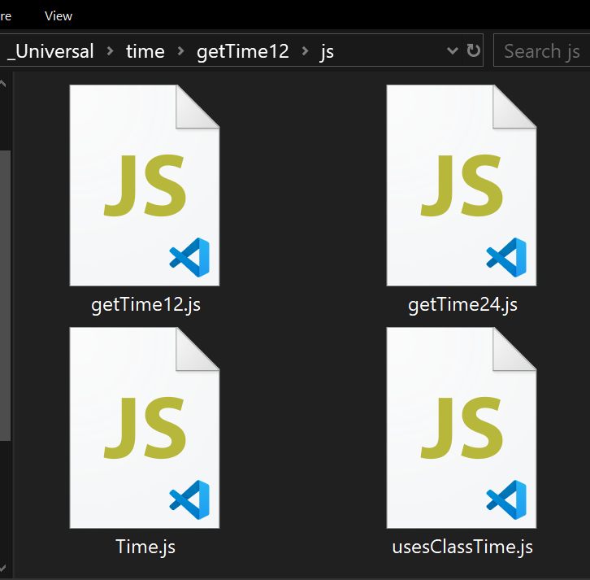

In this project folder, we have 4 files:
// getTime12.js
// getTime24.js
// Time.js
// usesClassTime.js

// getTime12.js

function getTime12()
{
// new date object for current date and time
let now = new Date();

// time as 12 hour format AM/PM
let hours = now.getHours();
let minutes = now.getMinutes();
let seconds = now.getSeconds();
let ampm;

// determine AM or PM
if (hours >= 12)
{
ampm = 'PM';
}
else
{
ampm = 'AM';
}

// convert to 12 hour format
hours = hours % 12;

if (hours === 0)
{
// the hour 0 should be 12
hours = 12;
}

// pad minutes with leading zeros if needed
if (minutes < 10)
{
minutes = '0' + minutes;
}

// pad seconds with leading zeros if needed
if (seconds < 10)
{
seconds = '0' + seconds;
}

// return formatted time
return hours + ':' + minutes + ':' + seconds + ' ' + ampm;
}

if (require.main === module)
{
console.log(getTime12());
}

module.exports = getTime12;

//----//

/*
4:15:30 PM
*/

// Dedicated to God the Father
// All Rights Reserved Christopher Andrew Topalian Copyright 2000-2024
// https://github.com/ChristopherTopalian
// https://github.com/ChristopherAndrewTopalian
// https://sites.google.com/view/CollegeOfScripting
// getTime24.js

function getTime24()
{
// new date object for current date and time
let now = new Date();

// time as 12 hour format AM/PM
let hours = now.getHours();
let minutes = now.getMinutes();
let seconds = now.getSeconds();

if (hours === 0)
{
// the hour 0 should be 12
hours = 12;
}

// pad minutes with leading zeros if needed
if (minutes < 10)
{
minutes = '0' + minutes;
}

// pad seconds with leading zeros if needed
if (seconds < 10)
{
seconds = '0' + seconds;
}

// return formatted time
return hours + ':' + minutes + ':' + seconds;
}

if (require.main === module)
{
console.log(getTime24());
}

module.exports = getTime24;

//----//

/*
19:10:55
*/

// Dedicated to God the Father
// All Rights Reserved Christopher Andrew Topalian Copyright 2000-2024
// https://github.com/ChristopherTopalian
// https://github.com/ChristopherAndrewTopalian
// https://sites.google.com/view/CollegeOfScripting

// Time.js

const getTime12 = require('./getTime12.js');
const getTime24 = require('./getTime24.js');

// class that uses imported functions
class Time
{
static getTime12()
{
return getTime12();
}

static getTime24()
{
return getTime24();
}
}

module.exports = Time;

//----//

// Dedicated to God the Father
// All Rights Reserved Christopher Andrew Topalian Copyright 2000-2024
// https://github.com/ChristopherTopalian
// https://github.com/ChristopherAndrewTopalian
// https://sites.google.com/view/CollegeOfScripting

// usesClassTime.js

const Time = require('./Time.js');

console.log(Time.getTime12());
console.log(Time.getTime24());

process.stdin.resume();
process.stdin.once('data', function()
{
process.exit();
});

//----//

/*
7:15:47 PM
19:15:47
*/

// Dedicated to God the Father
// All Rights Reserved Christopher Andrew Topalian Copyright 2000-2024
// https://github.com/ChristopherTopalian
// https://github.com/ChristopherAndrewTopalian
// https://sites.google.com/view/CollegeOfScripting

python
Universal Coding Style
Python Universal Coding Style

In this project folder, we have 4 files:
// getTime12.py
// getTime24.py
// Time.py
// usesClassTime.py

getTime12.py is a function
getTime24.py is a function
Time.py is a class that imports our functions
usesClassTime.py uses our Time.js class

We achieve a very pure functional style of coding and enable namespace for our functions using our class import method.
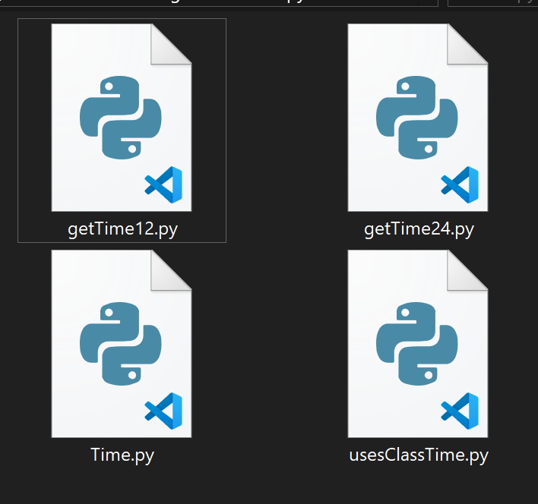

In this project folder, we have 4 files:
// getTime12.py
// getTime24.py
// Time.py
// usesClassTime.py
# getTime12.py

import datetime as dt

def getTime12():
now = dt.datetime.now()
currentTime = now.strftime("%I:%M:%S %p")
return currentTime

##

if __name__ == "__main__":
print(getTime12())
input('')

####

'''
05:43:07 PM
'''

# Dedicated to God the Father
# All Rights Reserved Christopher Andrew Topalian Copyright 2000-2024
# https://github.com/ChristopherTopalian
# https://github.com/ChristopherAndrewTopalian
# https://sites.google.com/view/CollegeOfScripting

# getTime24.py

import datetime as dt

def getTime24():
now = dt.datetime.now()
currentTime = now.strftime("%H:%M:%S")
return currentTime

##

if __name__ == "__main__":
print(getTime24())
input('')

####

'''
19:30:10
'''

# Dedicated to God the Father
# All Rights Reserved Christopher Andrew Topalian Copyright 2000-2024
# https://github.com/ChristopherTopalian
# https://github.com/ChristopherAndrewTopalian
# https://sites.google.com/view/CollegeOfScripting

# Time.py

from getTime12 import getTime12
from getTime24 import getTime24

class Time:
getTime12 = getTime12
getTime24 = getTime24

##

# Dedicated to God the Father
# All Rights Reserved Christopher Andrew Topalian Copyright 2000-2024
# https://github.com/ChristopherTopalian
# https://github.com/ChristopherAndrewTopalian
# usesClassTime.py

import Time

print(Time.getTime12())
print(Time.getTime24())

input('')

####

'''
07:35:41 PM
19:35:41
'''

# Dedicated to God the Father
# All Rights Reserved Christopher Andrew Topalian Copyright 2000-2024
# https://github.com/ChristopherTopalian
# https://github.com/ChristopherAndrewTopalian
# https://sites.google.com/view/CollegeOfScripting

True Artificial Intelligence System
Tautology
1111
Contra-
-diction
0000
XOR
0110
XNOR
1001
AND
0001
NAND
1110
OR
0111
NOR
1000
MI
1101
MNI
0010
LP
0011
LC
1100
RP
0101
RC
1010
CI
1011
CNI
0100
16-Gon
For More Tutorials:

GitHub.com/ChristopherTopalian
GitHub.com/ChristopherAndrewTopalian
Sites.google.com/view/CollegeOfScripting
CollegeOfScripting.weebly.com
CollegeOfScripting.wordpress.com
Youtube.com/ScriptingCollege
Twitter.com/CollegeOfScript
Rumble.com/user/CollegeOfScripting
Dedicated to God the Father
This book is created by the
College of Scripting Music & Science.
Always remember, that each time you write a script with a pencil and paper, it becomes imprinted so deeply in memory that the material and methods are learned extremely well.

When you Type the scripts, the same is true. The more you type and write out the scripts by keyboard or pencil and paper, the more you will learn programming!

Write and Type every example that you find.
Keep all of your scripts organized.
Every script that you create increases your programming abilities.
SEEING CODE, is one thing,
but WRITING CODE is another.
Write it, Type it, Speak it, See it, Dream it.
CollegeOfScripting.weebly.com

